***Big Game Census Data Visualization***

Wireframe Documentation

- **sujith reddy**

**Dashboard**

The given data is visualized on Tableau Desktop and published on Tableau Public. The dashboard given below can be accessed using the link:

The dashboard contains 5 separate sheets or visualizations and their details about them are given below.

# BIG GAME CENSUS DATA VISUALIZATION DASHBOARD

The following information can be accessed from the dashboard:

* + Is someone from your hometown in the game?
  + All States with Number of Players, Players Teams & Average Player Age
  + All Teams with their Avg. Player Age, Avg. Years Played, Median Player Weight & Conference
  + Player Birthplace with its 2016 Population Estimates

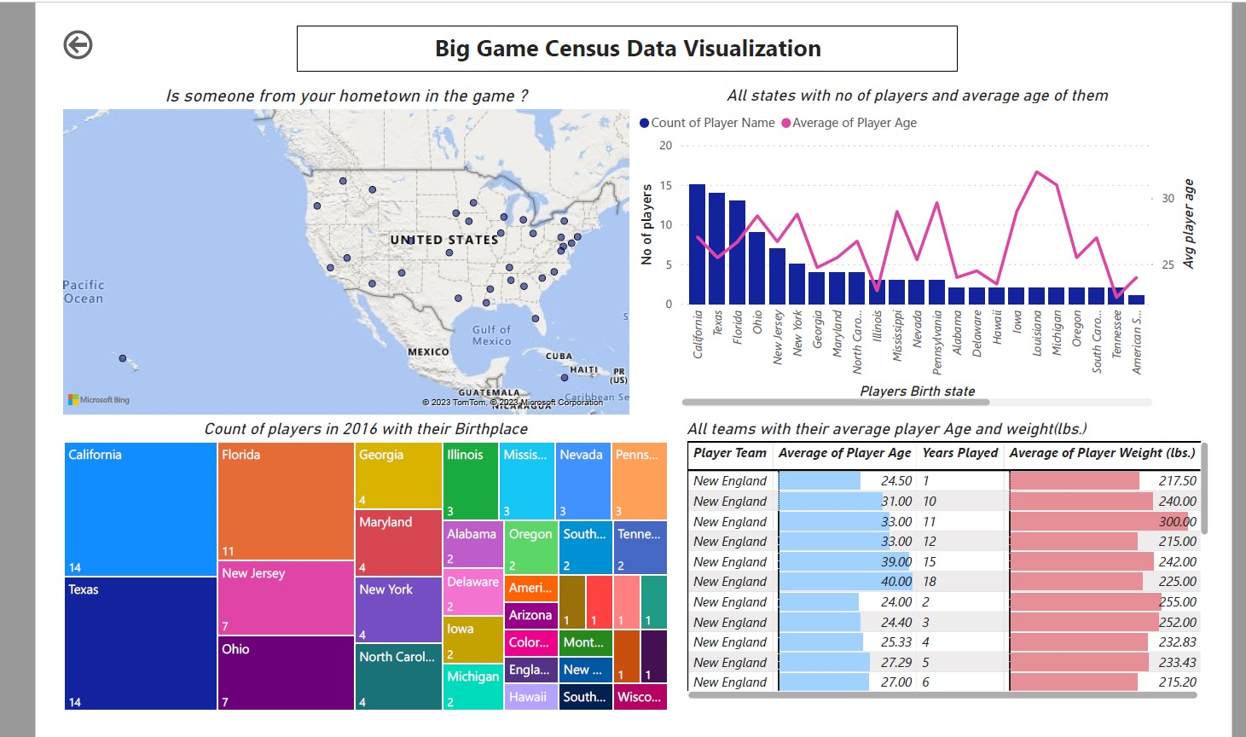

# IS SOMEONE FROM YOUR HOMETOWN IN THE GAME?

This visualization shows total number of players from all states along with the teams to which they belong.

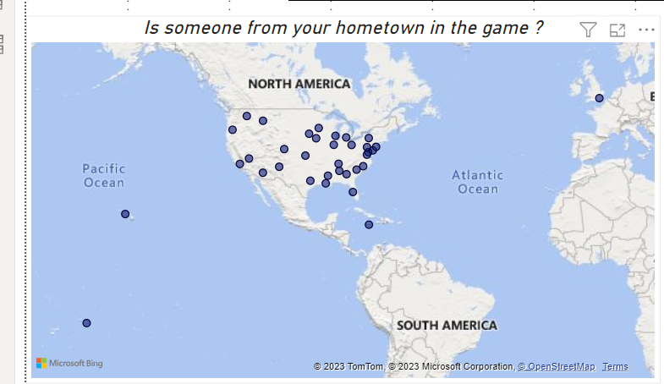

# PLAYER BIRTHPLACE WITH ITS 2016 POPULATION ESTIMATES

This visualization shows birthplace (city and state) of all players along with the estimated population of that place for year 2016.

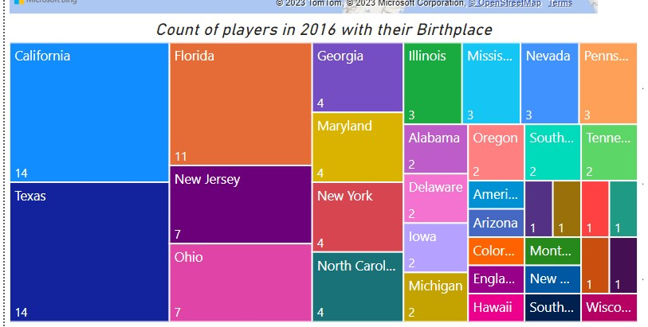

# ALL STATES WITH NUMBER OF PLAYERS, PLAYERS TEAMS & AVERAGE PLAYER AGE

This visualization shows the Player Birth state, Player Team, Average Player Age, Number of players from the hovered state and team.

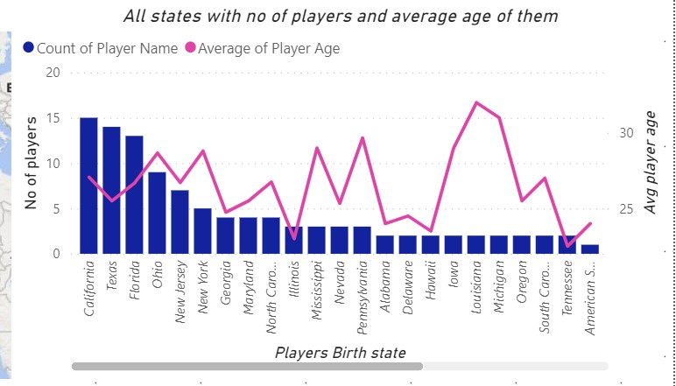

# ALL TEAMS WITH THEIR AVERAGE PLAYER AGE, AVERAGE YEARS PLAYED, MEDIAN PLAYER WEIGHT & CONFERENCE

This visualization shows the Player Teams, Average Player Age, Average. Years Played and Median player weight in lbs.

